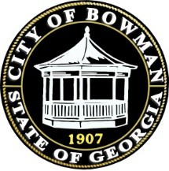

**Agenda Bowman monthly meeting**

**Wednesday December 11th, 2024, 6:30 pm**

**City Hall**

1. Call to order
2. Prayer
3. Pledge of Allegiance
4. Approval of minutes (November 13th, 2024)
5. 2nd reading of GMA Retirement Ordinance
6. Senior Luncheon
7. ARPA Funds
8. Employee Christmas Bonus
9. Renewal of Business Licenses
10. Renewal of Beer and Wine Licenses
11. Mayor report
12. Council member reports
13. Hospital Authority
14. Executive session
15. Adjournment